Denzyl Johnson

Martin Lawton

Jay Patel

James Patton

**What is the problem:**

Our Project will be based on the Science Fiction Fantasy Federation (SF3) held and maintained at UNCG. The organization started as a club with the focus of appealing to Star Trek fans, but has now has expanded to something larger. The current problem with SF3’s system is that all records of attendance with the organization is done manually using excel. The problem with this system is that the process is time consuming and hard to maintain. Our idea is to automate SF3’s current process by creating a Visual Basic application that keeps track of attendance of all the club’s attendees.

**Description:**

The interface will have a textbox for members to add their attendance. There will be a drop-down list to make it easier and improve efficiency for members to click on their name. Checkboxes will be made for officers for the organization. Officers will just check in their role and then be automatically be marked present on attendance. A form to report weekly attendance and information. A report to show semester wide statistics. The first function to add a user and the Second function for modifying user information from there the third function show output of the week and the last function shows the end of semester information.

**Data stored:**

The data will contain the Names of each person, emails of their choosing, and the times they visited. The role the user has (visitor, full member, or officer role). The data should be able to be queried for the number of unique people and percentage attending each week. The email of each user will be the primary key. The database will be a local Microsoft SQL database. Within the SQL database, we plan on having data such as the names of members, who attended the meeting, date that members attended the meetings and what the member's role are.

**Registration form:** 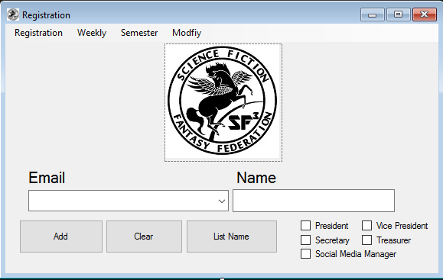

When you first open the program you are greeted to this form. If you are already in our database all you need to do is enter the email address. If you are not in our database you will then add yourself with your name. The checkboxes are used for our officers. They do not need to enter their email or name because they are already in our database. List name button will list the database showing everyone who was added this session to the database.

**Weekly Report Form:**

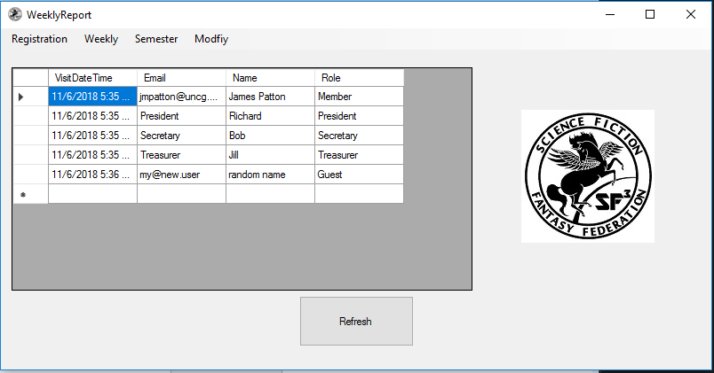

This form shows who attended last week’s meetings (7 days from day ran). The form updates when opened and again when the refresh button is pressed. The form shows the visit date and time first, then information on the visit (name, email, and role). If more records appear then the length given box then a scrollbar appears.

**Semester Form:**

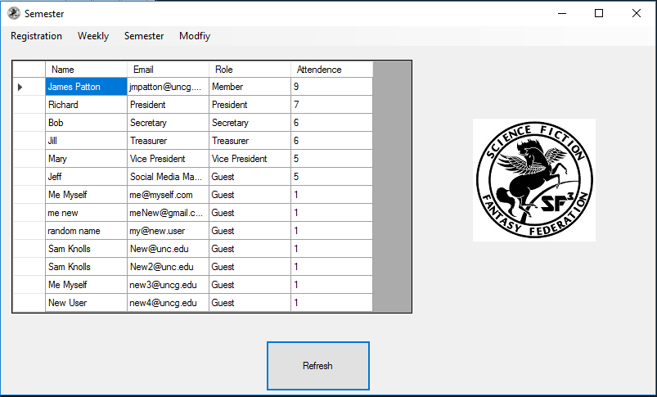

The semester form’s function is to keep track of each member’s attendance throughout the school semester. The refresh button updates the listings in the database to show its current status, given that something has changed since the last instance. The member’s name, email, role, and attendance are given to show the user of who’s attendance is being tracked along with the number of times they have attended. The form will track 105 days out of the year, around the typical amount for a school semester.

**Modify Form:**

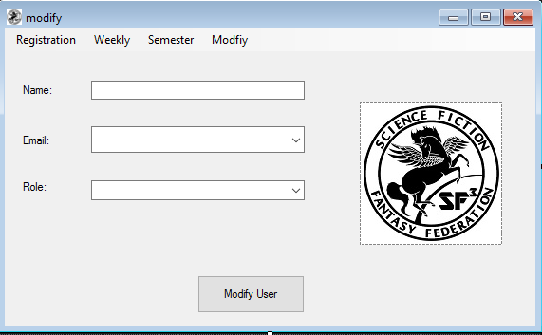

This modify report is used when a member needs to change their name or role. User can only modify from the two dropboxes from the form. After they enter their modification they can hit modify. After the user hits modify the modifications will change what was previously in the database